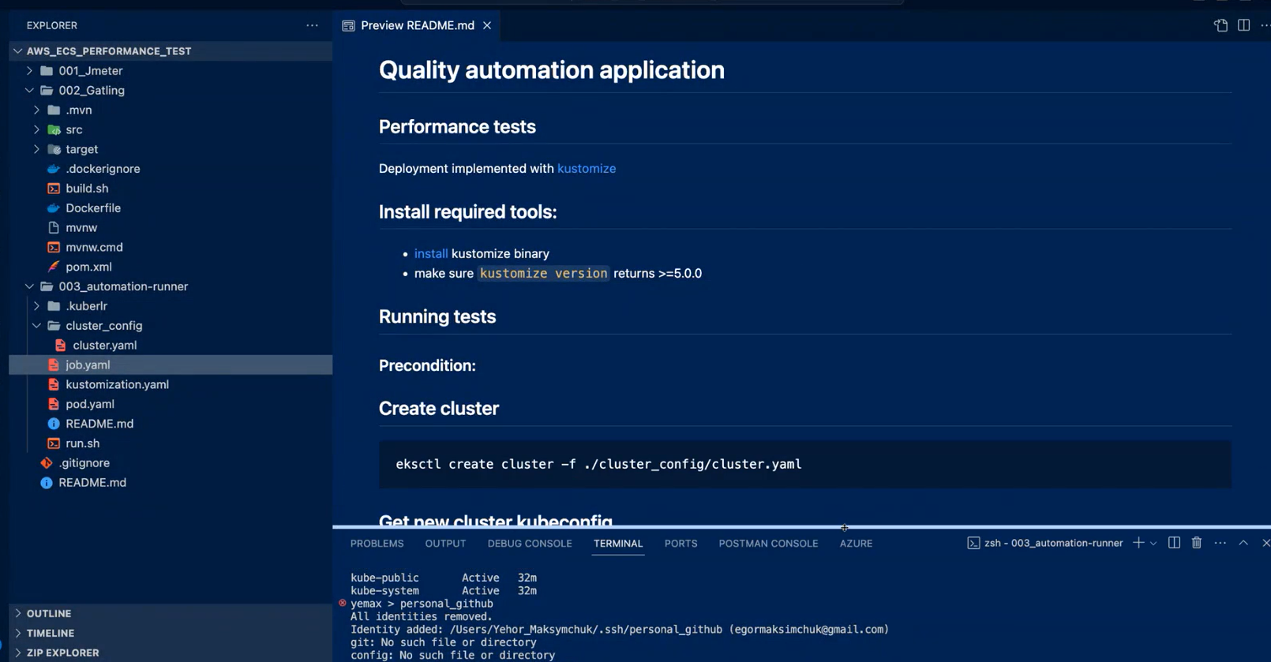

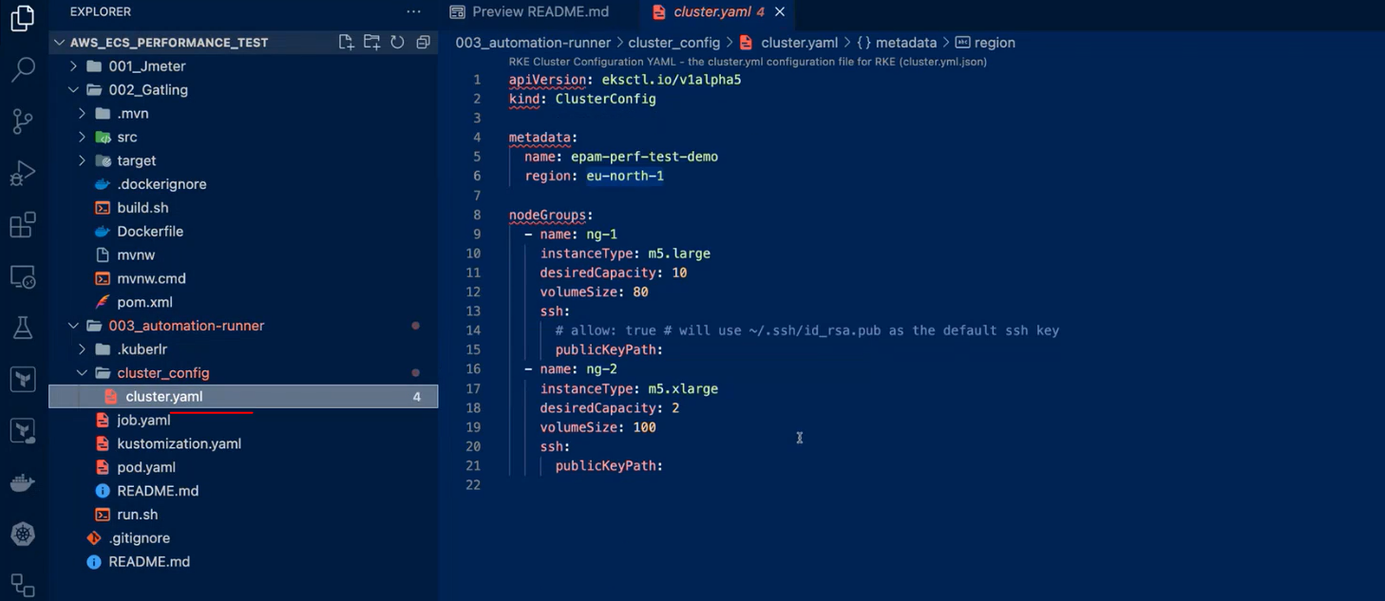

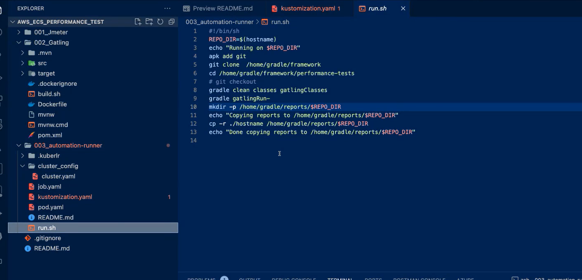

Change to :

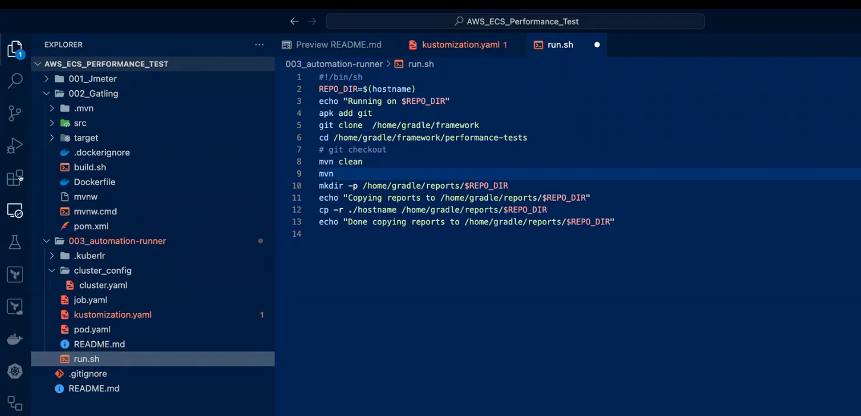

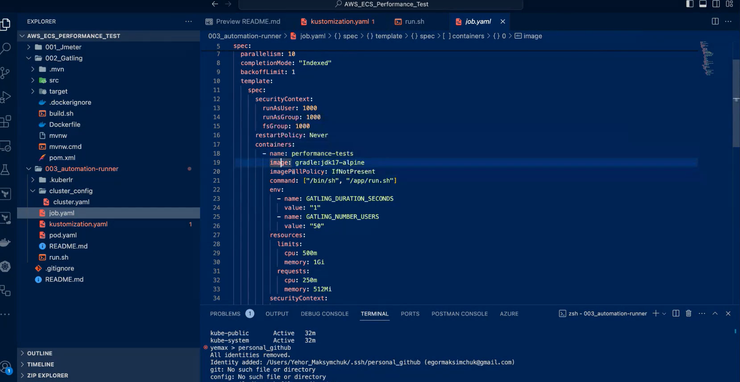

**Change to :**

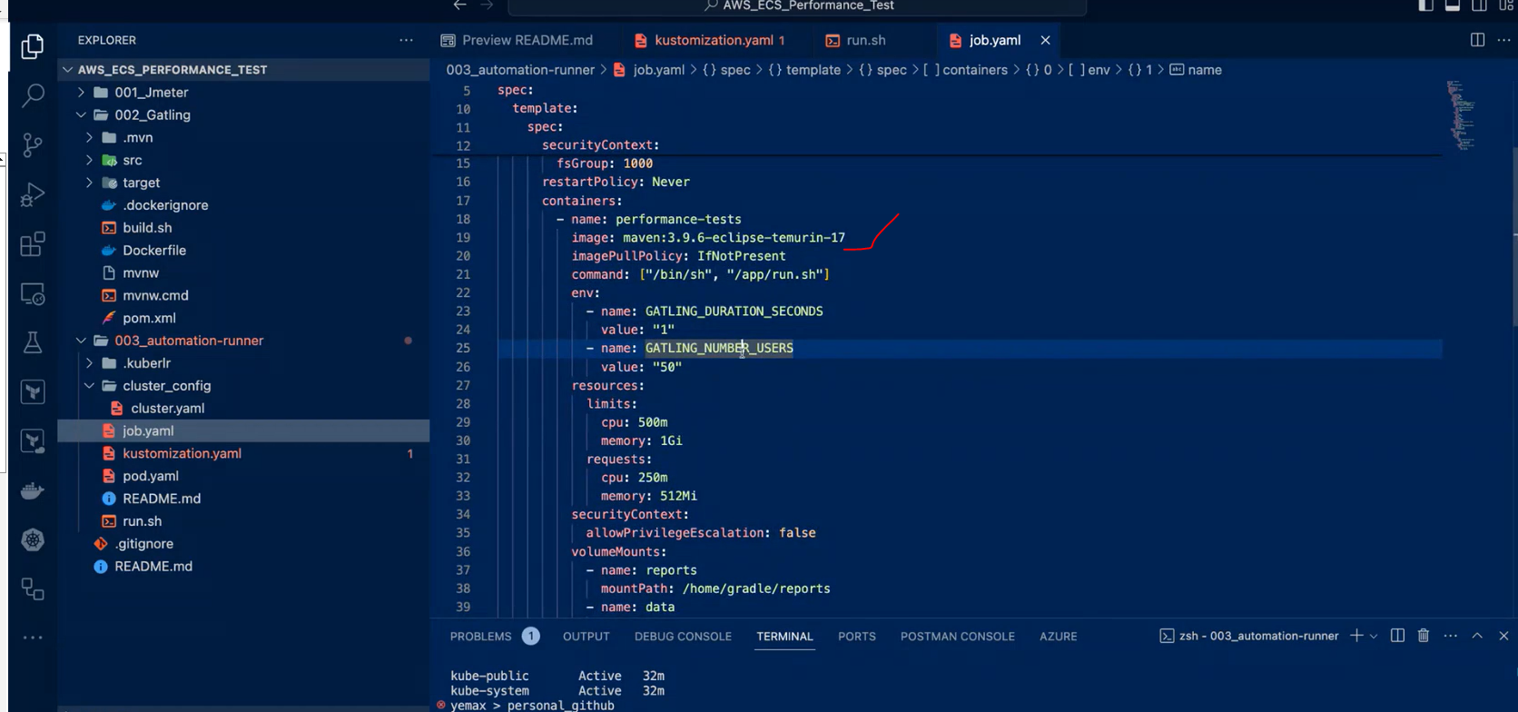

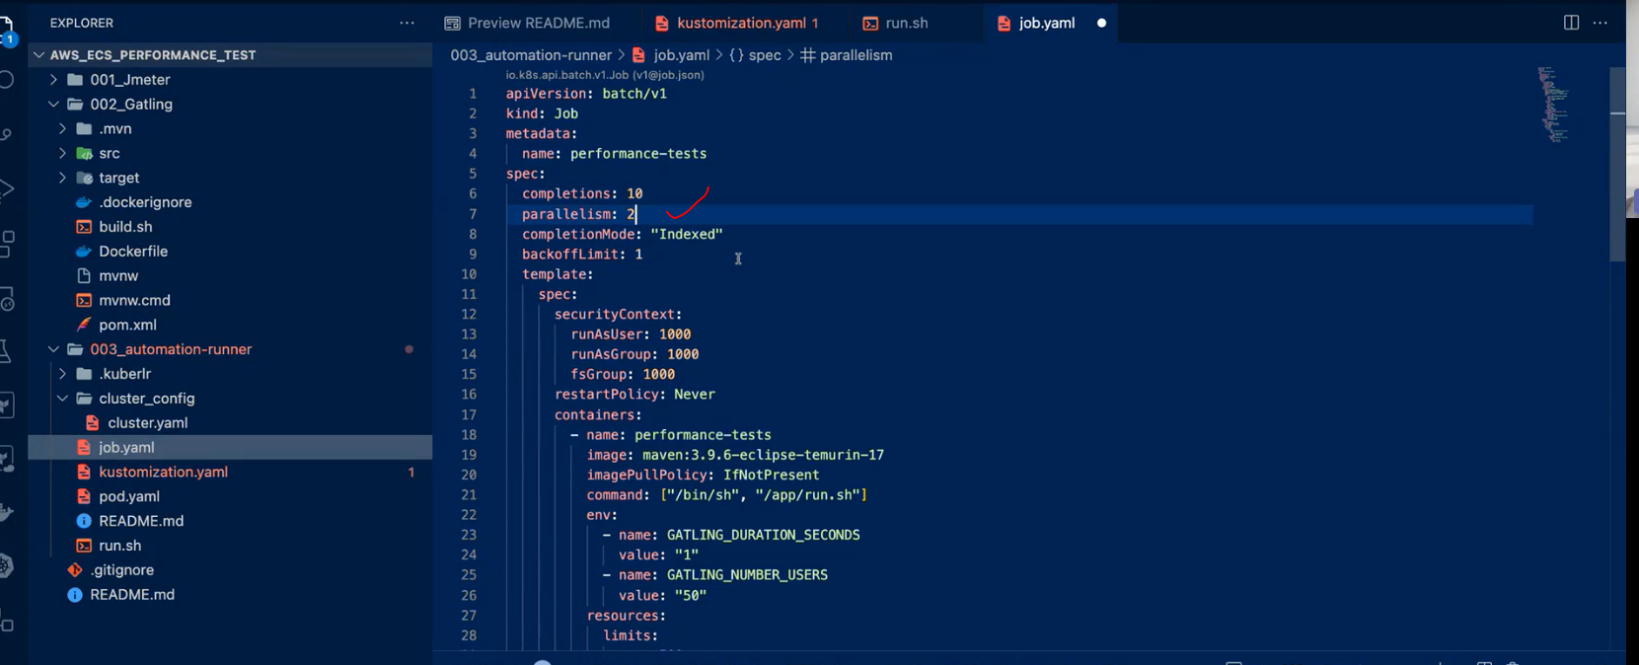

**Chang to:**

**Install Kustomize**

[**https://kustomize.io**](https://kustomize.io)

